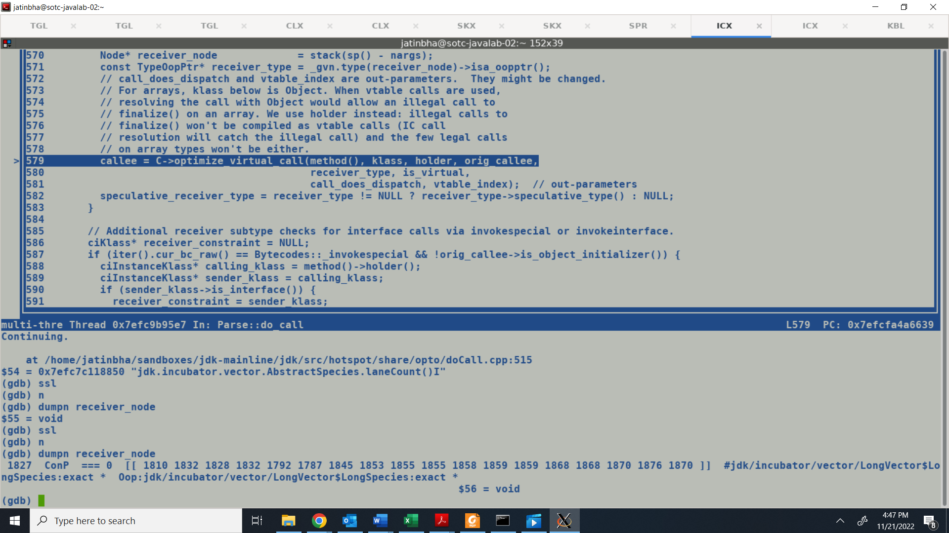

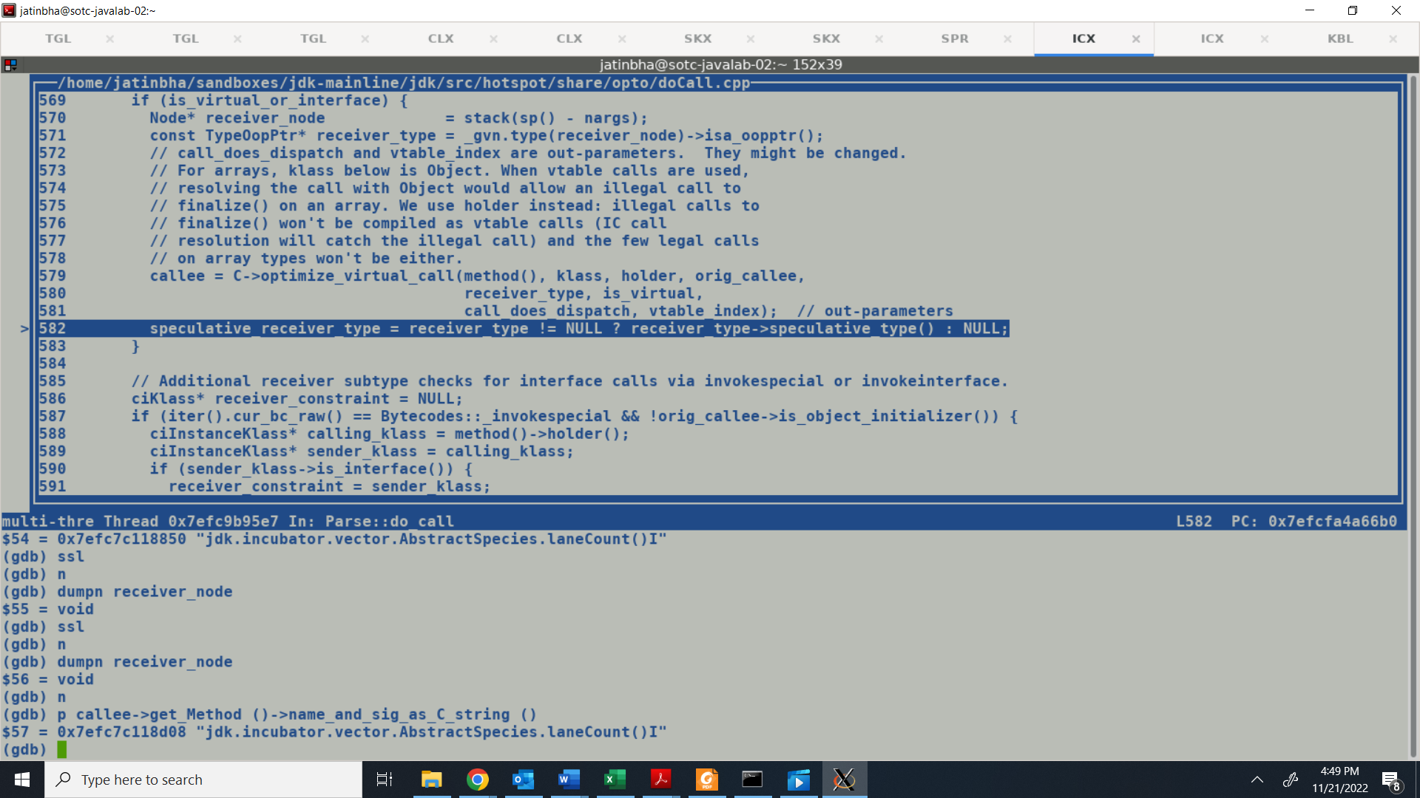

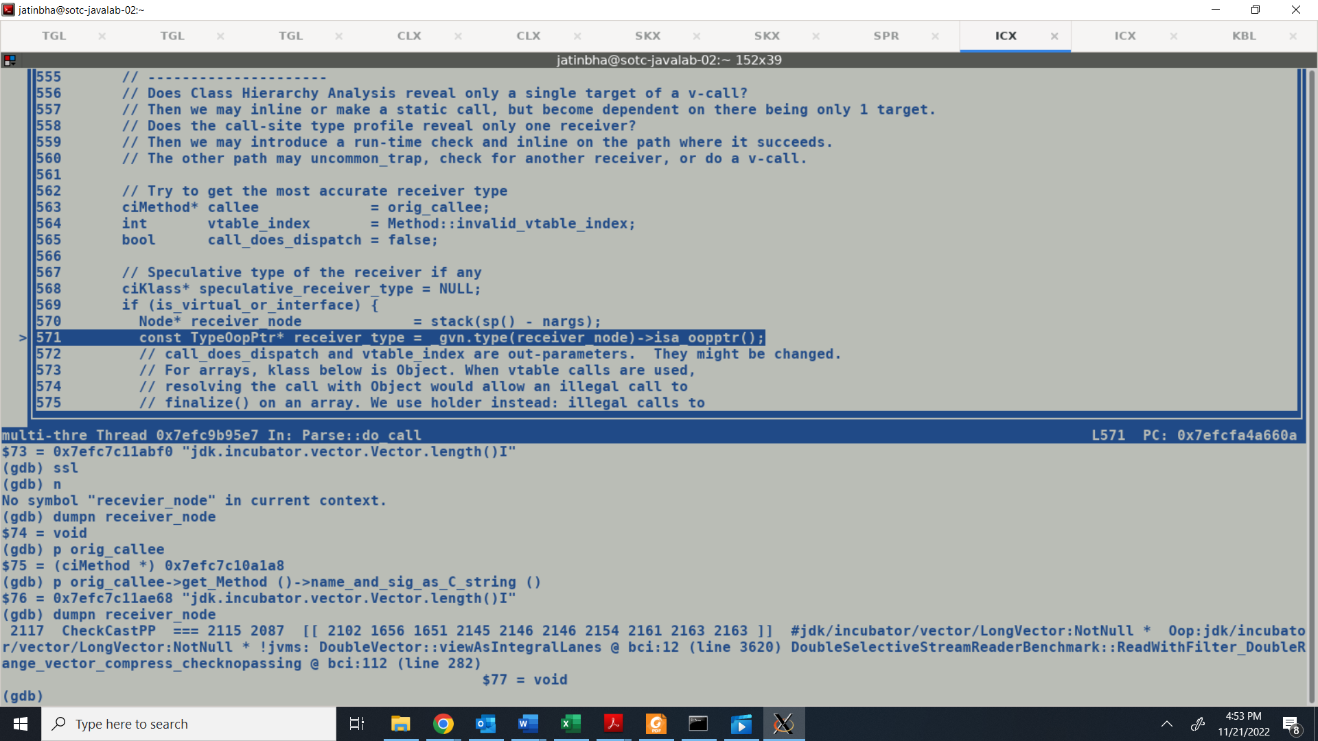

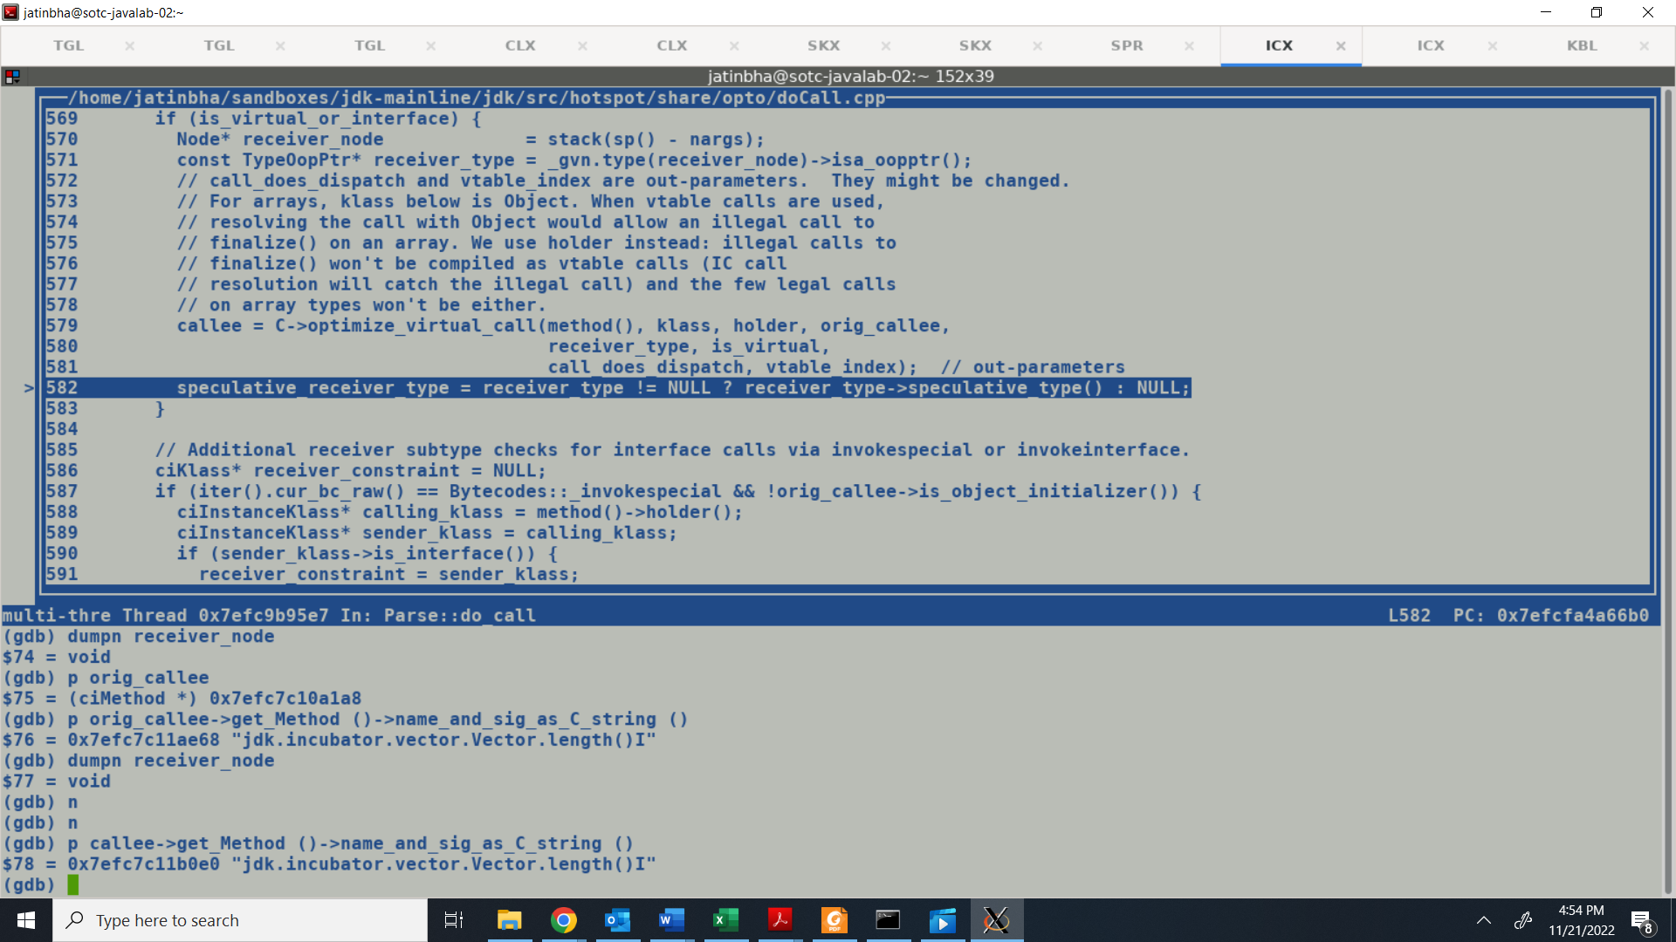

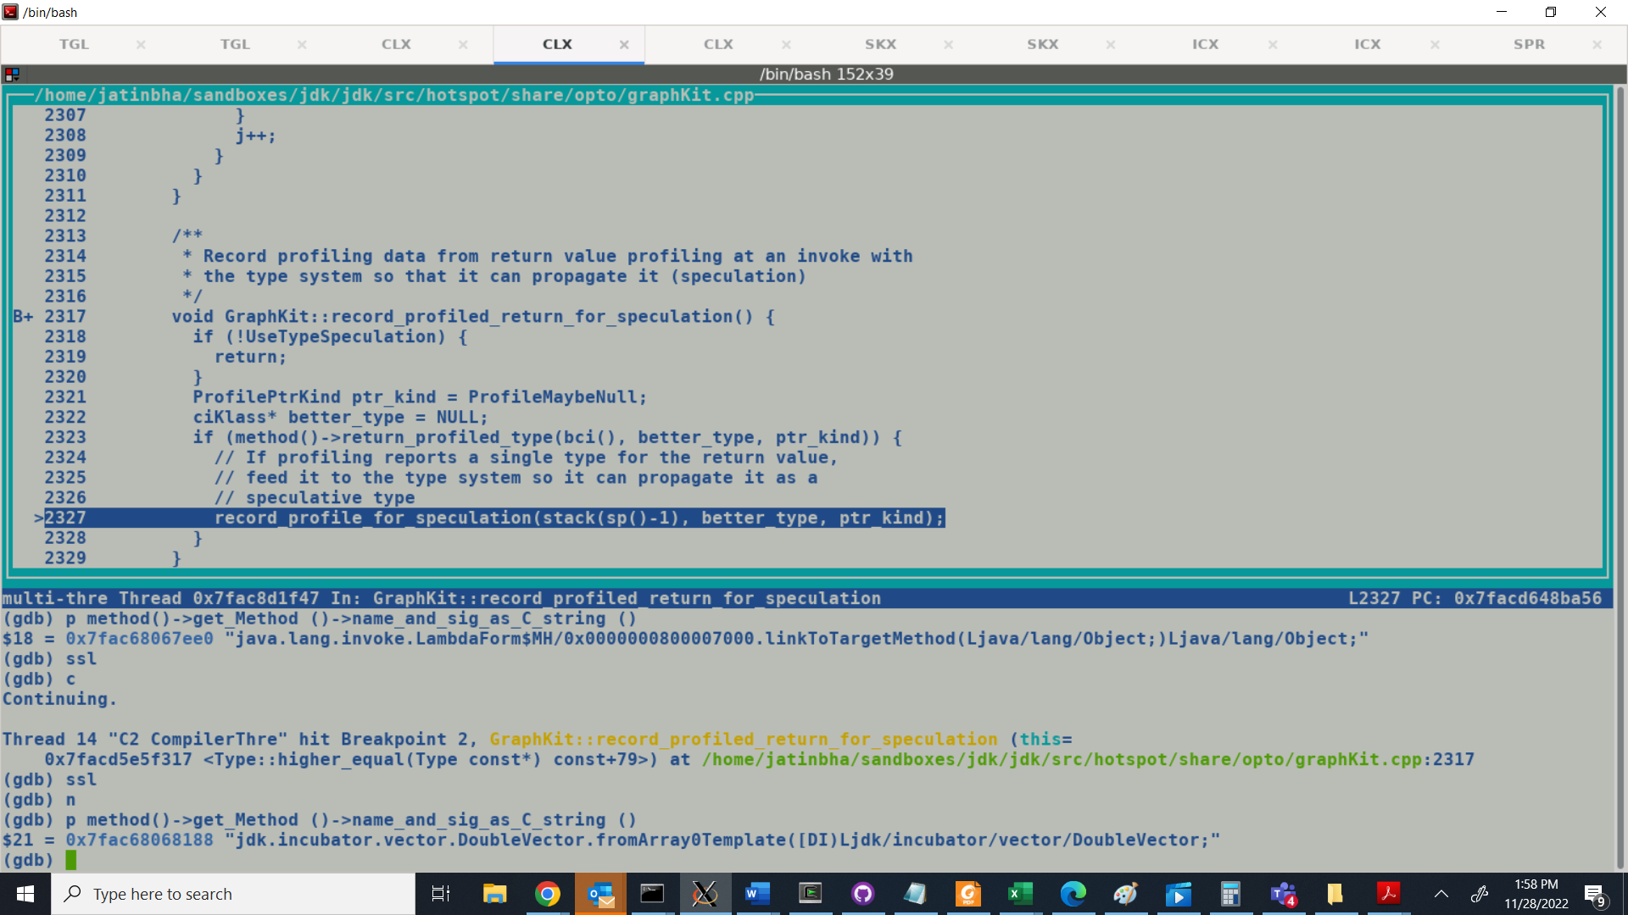

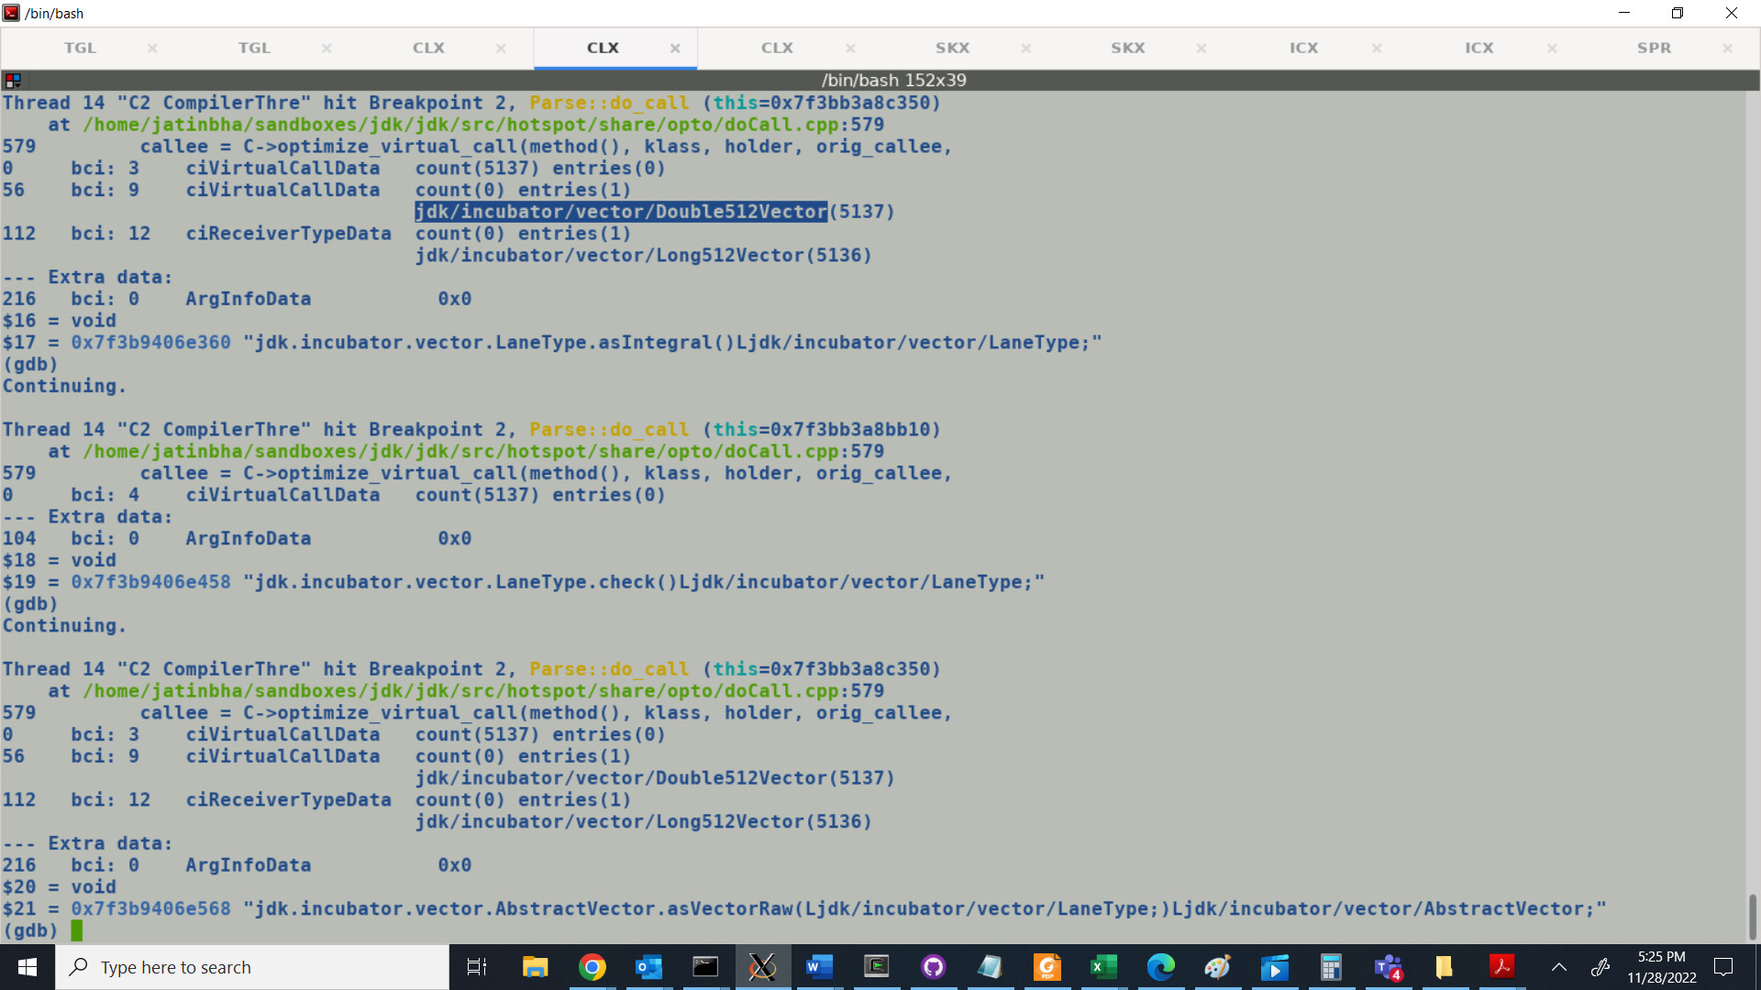

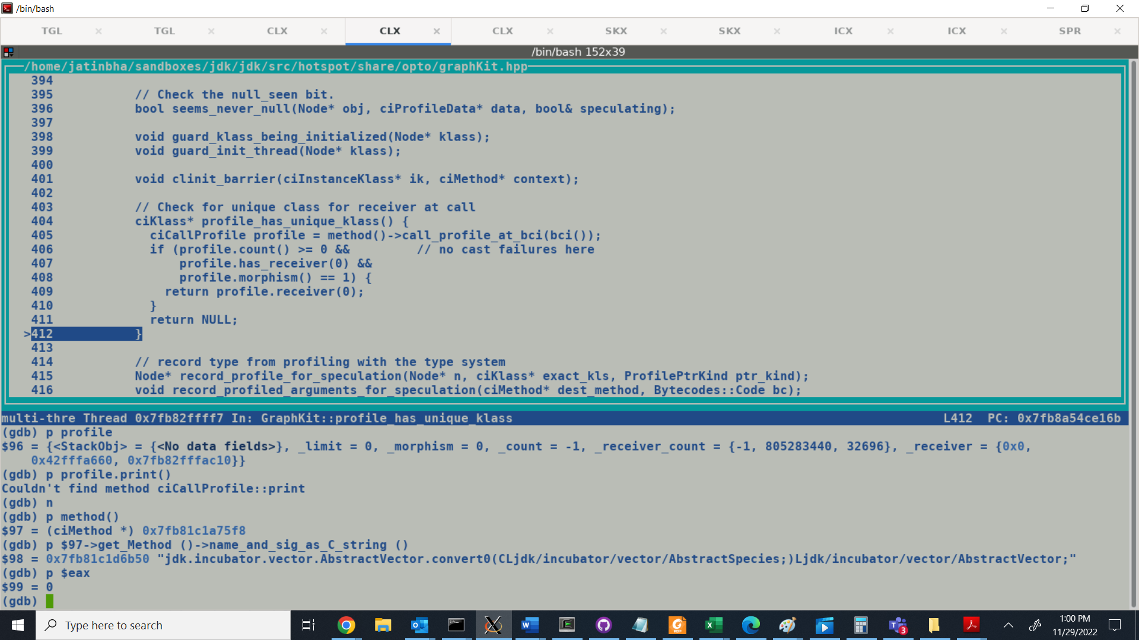

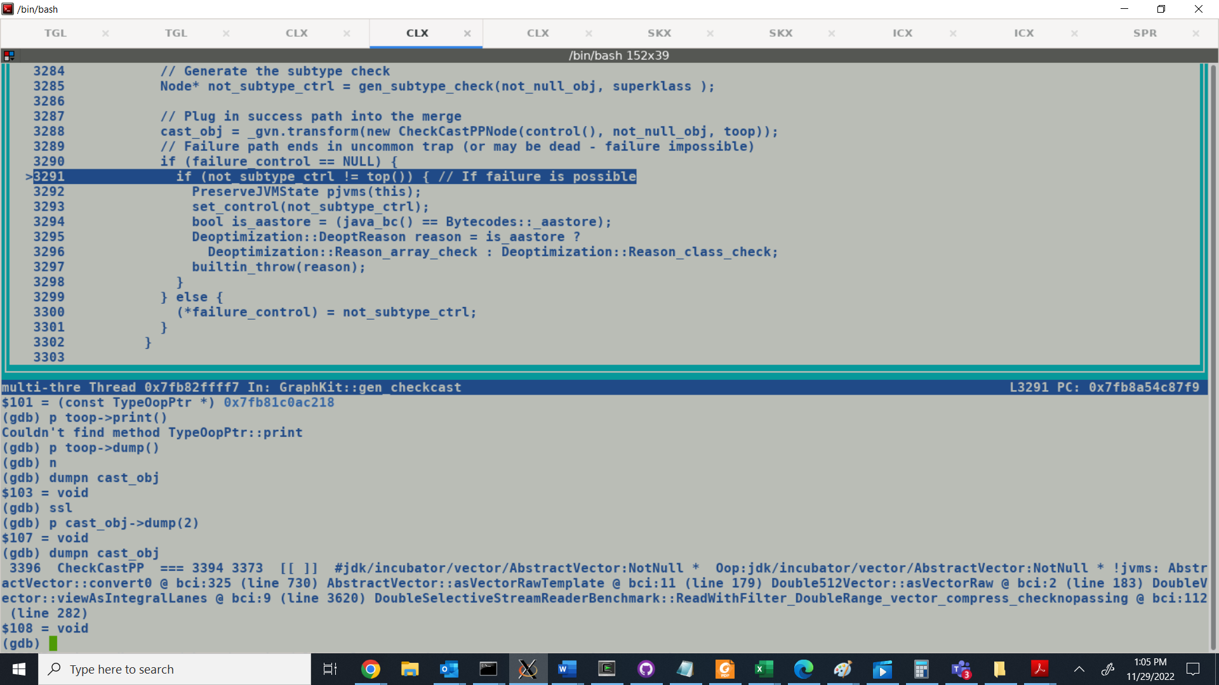

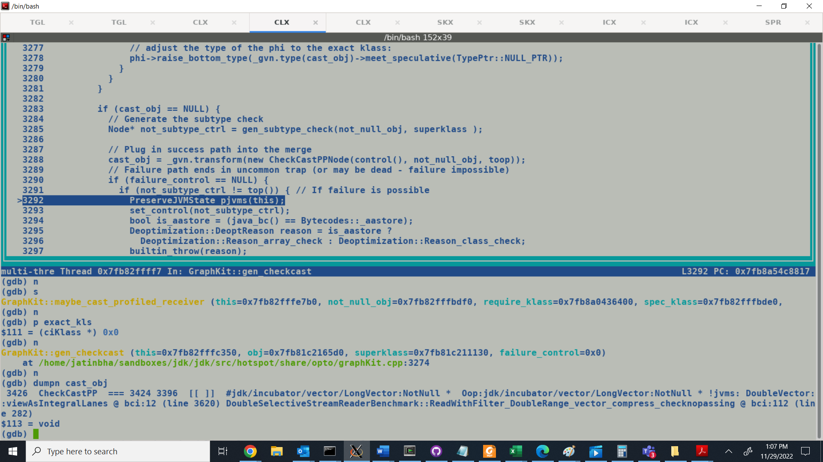



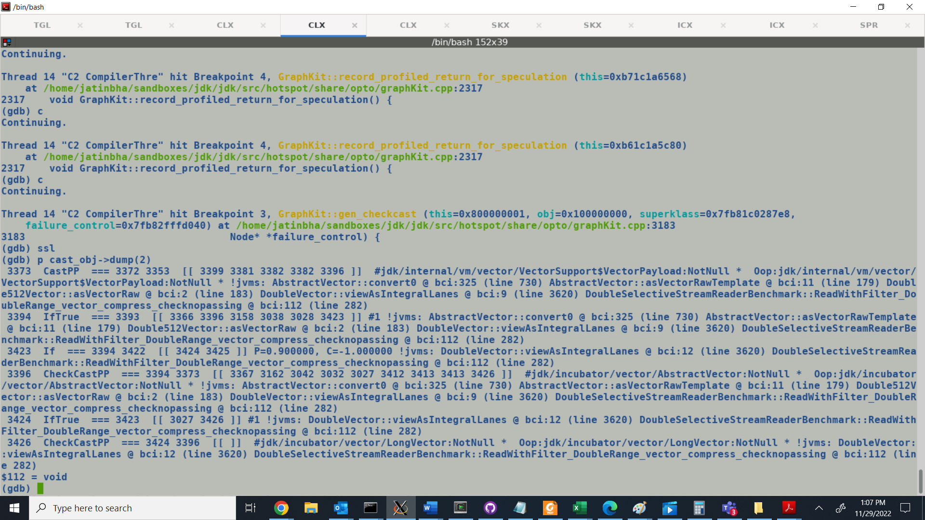

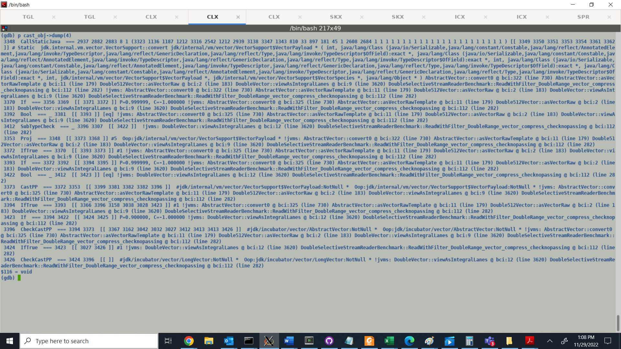

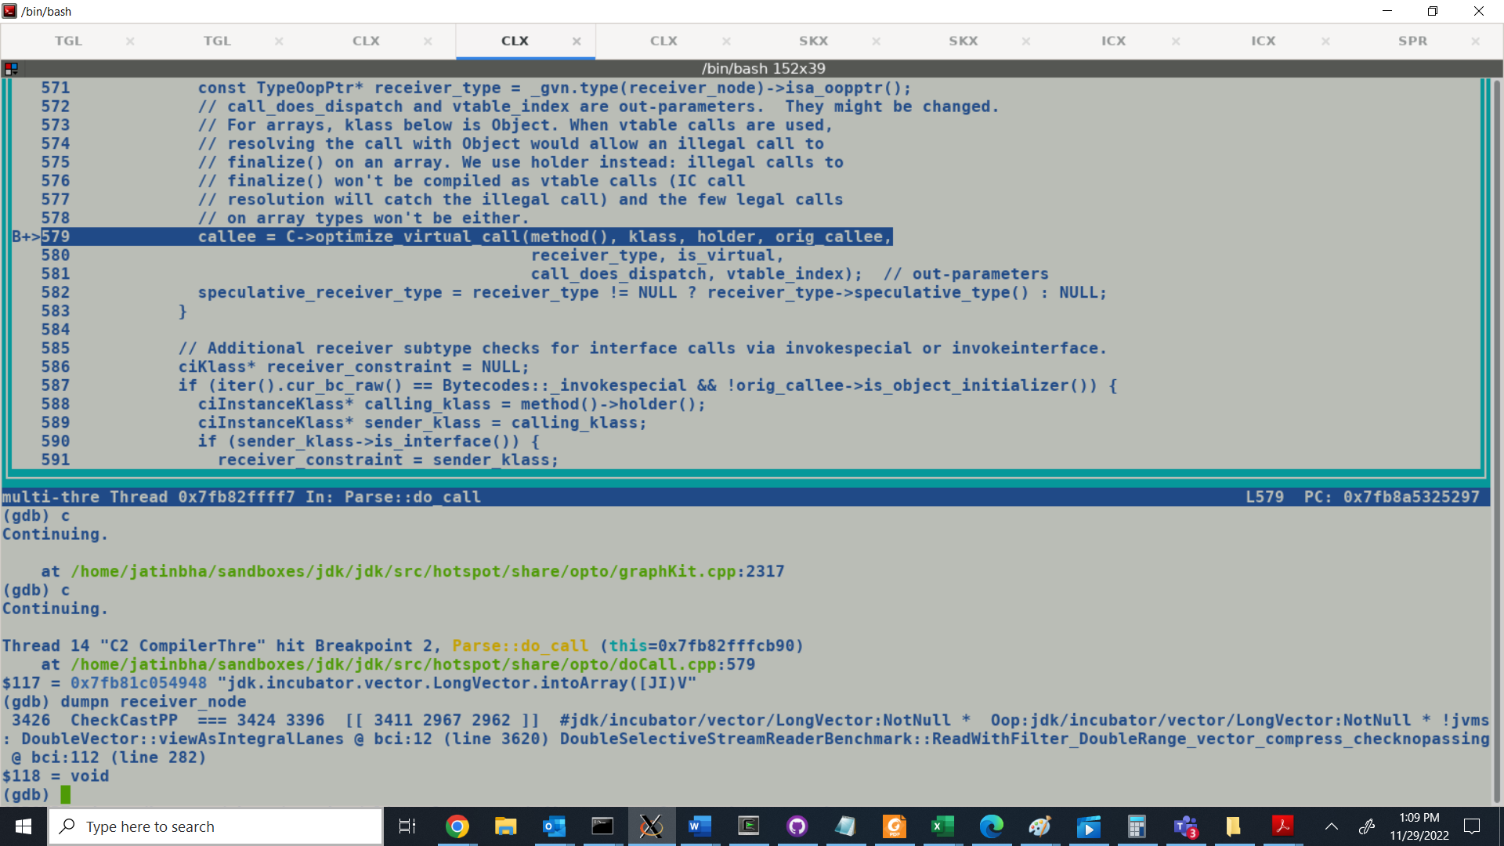

With Tiered Compilation, profiles are sufficient to pump the speculative types needed for granular checkcasting of Conversion IR there by facilitating accessor de-virtualization of lanetype and vectorclass methods needed to meet inline expander constraints.

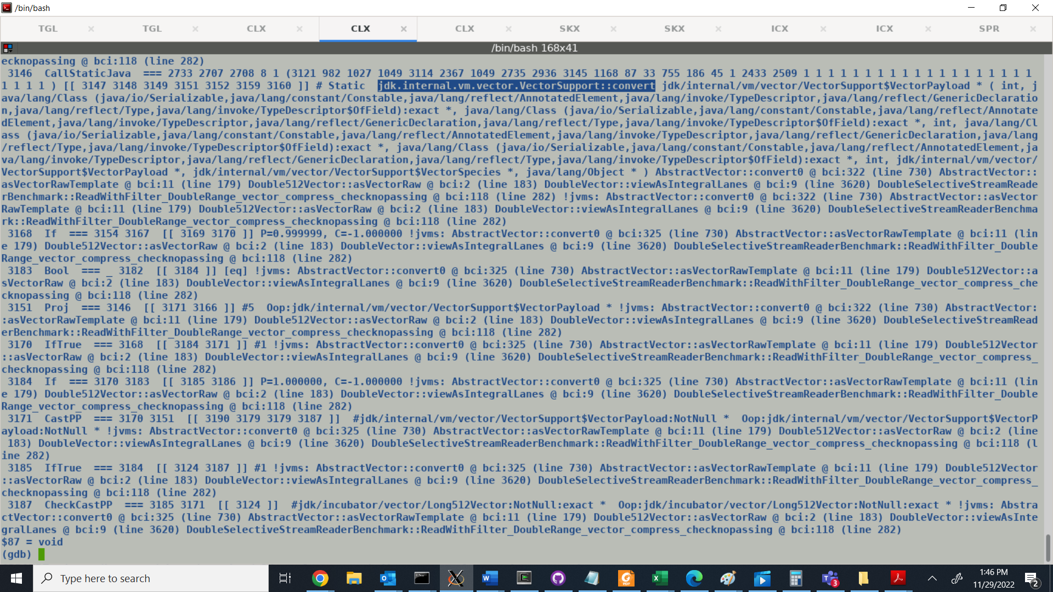

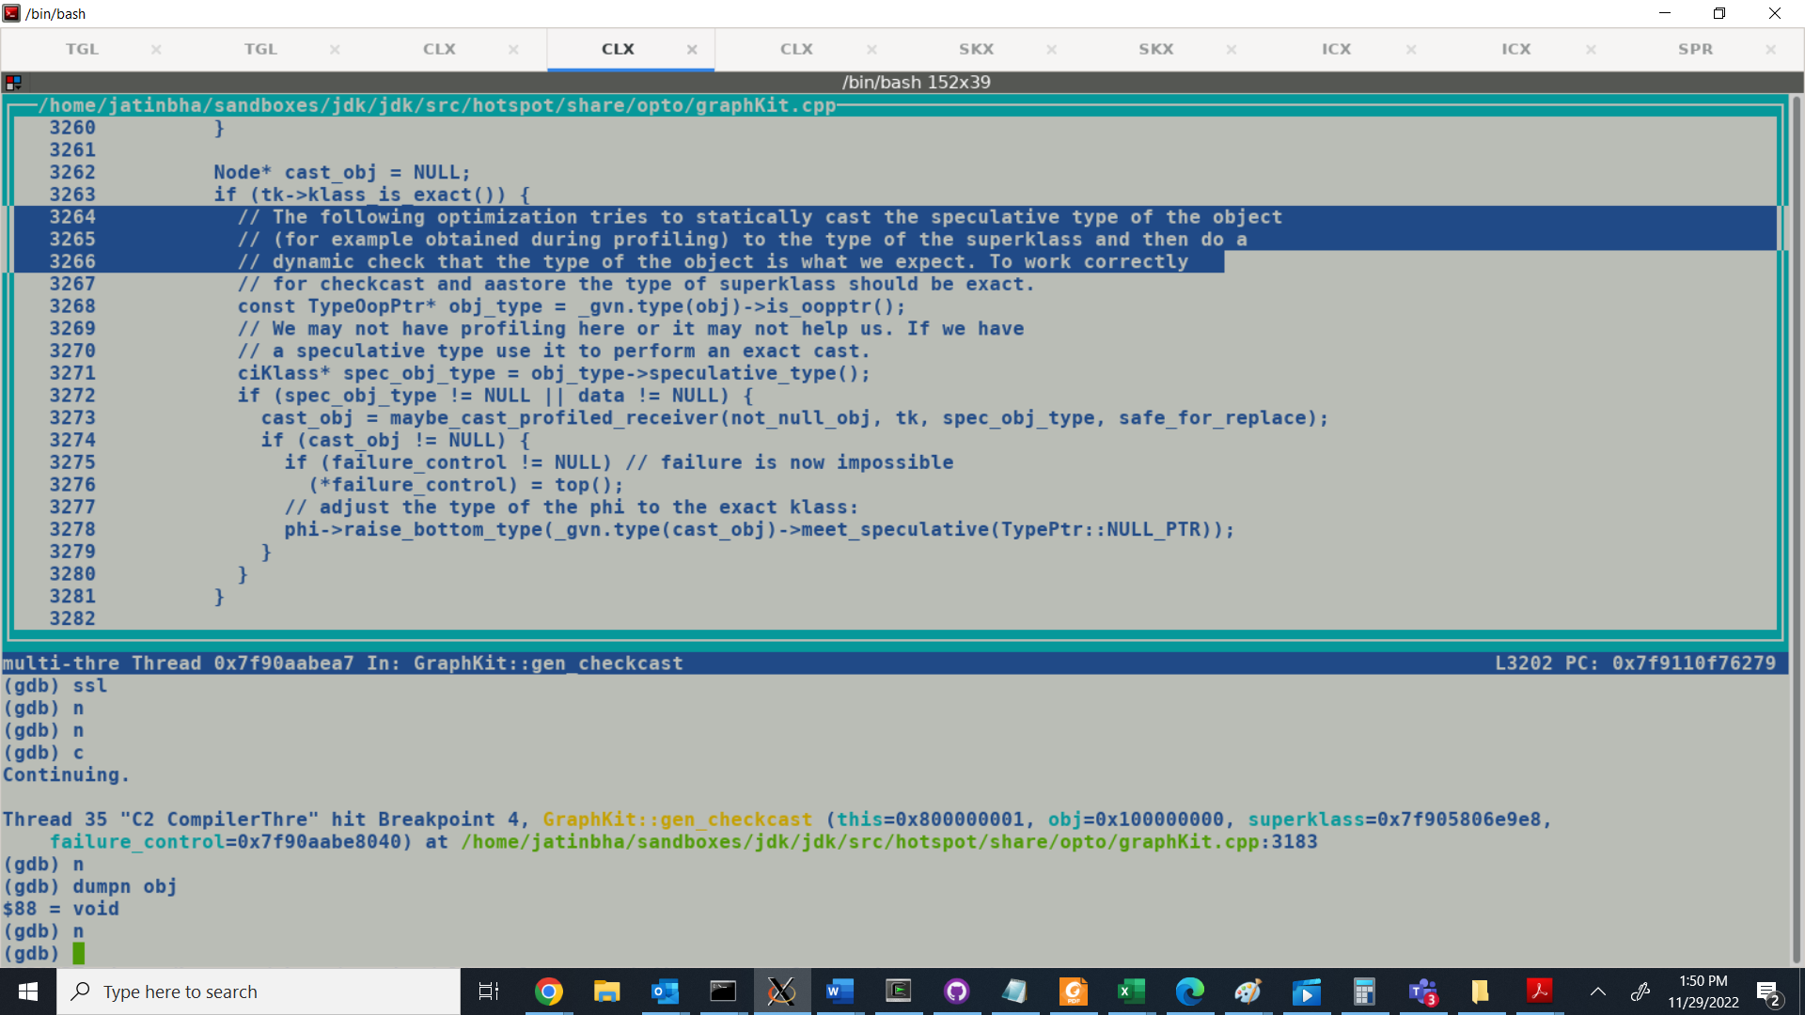

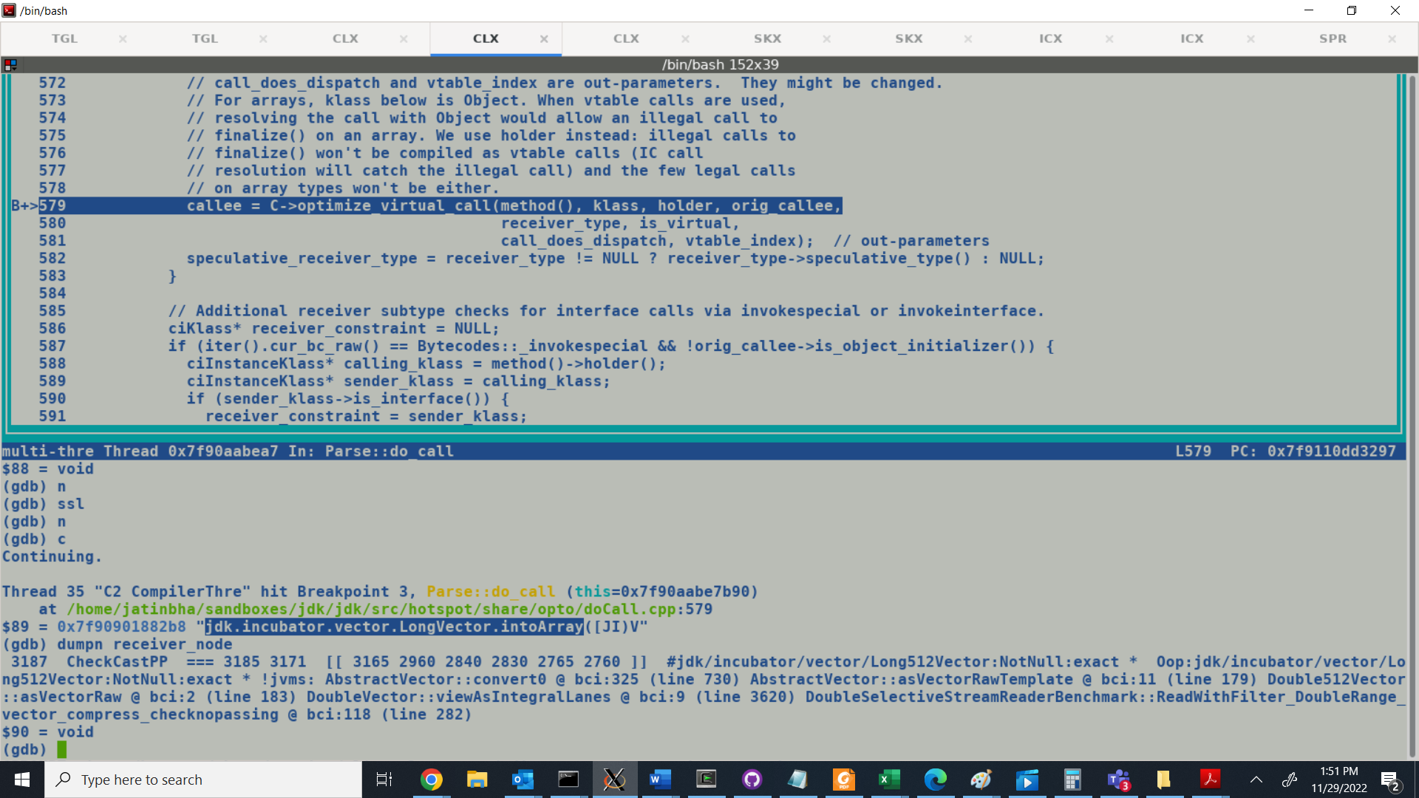

Runtime profiling: The MethodData object collects counts and other profile information during zeroth-tier (interpreter) and third-tier (C1 with full profiling) execution.

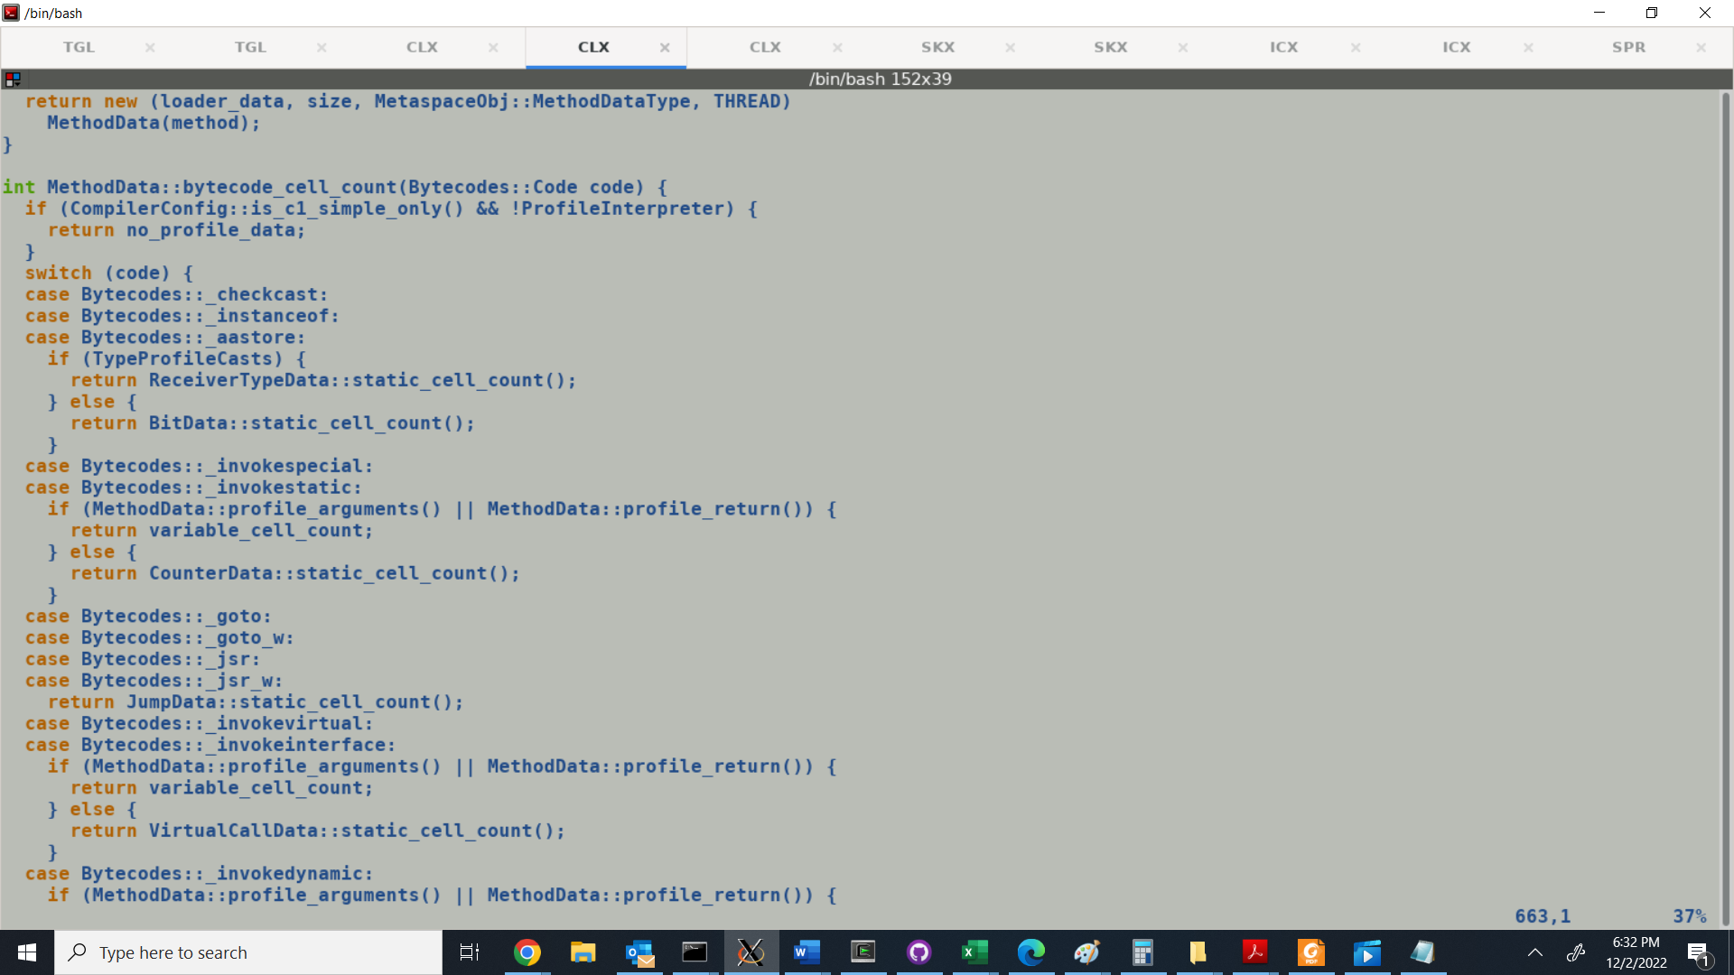

MethodData: Blank bytecode specific skeleton is constructed during MDO allocation.

This skeleton is later filled with appropriate profile information corresponding to relevant byte code[s]. C1 full profile compilation aggressively pumps profile information in MDO which is later used by top tier compiler during optimization passes. Any performance optimization based on speculative types adds relevant dependencies and emits predication constraints in method prologues which if fails directs the control toward uncommon traps.